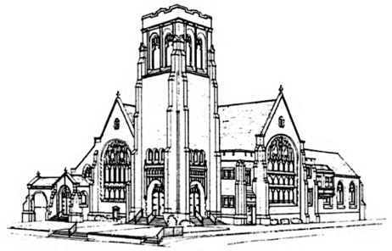
First Presbyterian Church

Fourth Sunday after Pentecost
June 25, 2023 at 10:00

THE CHURCH GATHERS

Handbell Chimes—The ringing of the chimes invites you to a time of Rest…Renewal…Hope

Prelude Rebecca Lentine, piano

Opening Sentences
One: From the rising of the sun to its setting
All: the Lord’s name is great among the nations.
One: The earth is the Lord’s and all that is in it;
All: the world, and all those who live in it.

* Hymn #407 (below) “When a Poor One”

* An Invitation to Experience God's Grace
One: When we pass through deep waters or go through times of fiery trial, the Lord our God is with us. With confidence in God, our creator and redeemer, let us confess our sin.

* Laying Down Our Burdens
All: God of Abraham, Sarah, and Isaac, God of Hagar and Ishmael, who gave us your Son, Jesus Christ the crucified, send your Holy Spirit to help us confess and truly repent of our sins. We turn against one another; we fail to care for the weak and poor among us. We pay no heed to the cries of the powerless; we seek our own advantage. Your Son emptied himself upon a Roman cross and revealed your eternal, self-giving love. Forgive us, merciful God. Wipe sin from our lives and let us find ourselves wholly in Jesus Christ, our Savior. It is in his name that we pray. Amen.

* Silent Prayer

* Declaration of Forgiveness
One: God, who loves us,
All: does not abandon or forsake us.
One: Our Savior hears and answers
All: when we cry out from the wastelands.
One: Death cannot bind us,
All: for the risen Christ sets us free.
One: Hear the Good News:
All: In Jesus Christ, we are forgiven. Thanks be to God! Amen.

* We Celebrate God’s Forgiveness #579 (insert) Glory Be to the Father (Gloria Patri)

* Sharing the Peace of Christ
One: The peace of our Lord Jesus Christ be with you all.
All: And also with you.
One: Let us greet one another with a sign of Christ’s peace.

Children’s Message

Celebrating the Life of the Congregation
(Please sign and pass the Friendship Registers and note those sitting around you)

GOD’S WORD PROCLAIMED

Prayer for Illumination
All: O God, you have the power to make a desert a place of renewal and a cross a sign of redemption. Send your Holy Spirit so that we can hear you and entrust ourselves completely to you, for the sake of Jesus Christ our Savior. Amen.

Gospel Reading Genesis 21: 8-21
The child grew, and was weaned; and Abraham made a great feast on the day that Isaac was weaned. But Sarah saw the son of Hagar the Egyptian, whom she had borne to Abraham, playing with her son Isaac. So she said to Abraham, “Cast out this slave woman with her son; for the son of this slave woman shall not inherit along with my son Isaac.” The matter was very distressing to Abraham on account of his son. But God said to Abraham, “Do not be distressed because of the boy and because of your slave woman; whatever Sarah says to you, do as she tells you, for it is through Isaac that offspring shall be named for you. As for the son of the slave woman, I will make a nation of him also, because he is your offspring.”
So Abraham rose early in the morning, and took bread and a skin of water, and gave it to Hagar, putting it on her shoulder, along with the child, and sent her away. And she departed, and wandered about in the wilderness of Beer-sheba. When the water in the skin was gone, she cast the child under one of the bushes. Then she went and sat down opposite him a good way off, about the distance of a bowshot; for she said, “Do not let me look on the death of the child.” And as she sat opposite him, she lifted up her voice and wept. And God heard the voice of the boy; and the angel of God called to Hagar from heaven, and said to her, “What troubles you, Hagar? Do not be afraid; for God has heard the voice of the boy where he is. Come, lift up the boy and hold him fast with your hand, for I will make a great nation of him.” Then God opened her eyes and she saw a well of water. She went, and filled the skin with water, and gave the boy a drink. God was with the boy, and he grew up; he lived in the wilderness, and became an expert with the bow. He lived in the wilderness of Paran; and his mother got a wife for him from the land of Egypt.

One: This is the Word of the Lord.
All: Thanks be to God.

Sermon “Hidden Figures” Rev. Nikki Passante

* Affirmation of Faith — The Apostles’ Creed (traditional) p. 14, The Presbyterian Hymnal
I believe in God the Father Almighty, Maker of heaven and earth, and in Jesus Christ his only Son our Lord; who was conceived by the Holy Ghost, born of the Virgin Mary, suffered under Pontius Pilate, was crucified, dead, and buried; he descended into hell; the third day he rose again from the dead; he ascended into heaven, and sitteth on the right hand of God the Father Almighty; from thence he shall come to judge the quick and the dead. I believe in the Holy Ghost; the holy catholic Church; the communion of saints; the forgiveness of sins; the resurrection of the body; and the life everlasting. Amen.

GIVE THANKS TO GOD

Prayers of the People and The Lord’s Prayer, p. 16, The Presbyterian Hymnal

Practicing Abundant Generosity
https://onrealm.org/FirstPresbyteri11244/give/now

Offertory: “Méditation“ (from Thaïs), by Jules Massenet, Tina Edmonston, cello
* Doxology #592 (insert) “Praise God from Whom All Blessings Flow”
* Recommitting Our Lives to Service

LEAVE TO SERVE

* Hymn #172 (below) “My Shepherd Will Supply My Need”

* Charge and Benediction

Sending Music Rebecca Lentine, piano

Please use the Postlude time and music to reflect on today’s worship experience and how it will support you in the week to come.

* Please stand in body or spirit

Reprinted / Podcast / Streamed with Permission Under OneLicense #740987-A. All Rights Reserved.

WELCOME TO FIRST PRESBYTERIAN CHURCH! It is good to have you here in person or online. Please be in touch if you have news to share or would like more information or to talk to a pastor. Staff contact information is below. Read full announcements in our weekly email newsletter, available on the church website. Subscribe on the Contact Us tab.

THE NURSERY is available in the Hospitality Center – across from Fellowship Hall.

AFTER-WORSHIP HOSPITALITY IS BACK! Linger a moment or two after the service to greet fellow worshippers. And please sign up with a friend or a group to host one Sunday by providing simple refreshments. There is a sign-up on the snack table or contact someone on the Hospitality Committee: jmfiorella@gmail.com, shoemakerjanet68@gmail.com, qlerch2@comcast.net, or phurd75@gmail.com,

PASTOR NIKKI LEADS SUMMER WORKSHOP SERIES BEGINS TODAY – This summer Pastor Nikki is offering three, one-hour workshops after Sunday worship in the Hospitality Center. Light snacks will be provided as well as ample time for questions and discussion!
Today: ‘Prayer’
Together we’ll look at numerous resources on prayer: books, noteworthy authors, and famous (and not-so-famous) prayers. Along with suggestions for leading and sustaining prayer groups, we’ll explore what scholars, pastors, and Jesus say about prayer. And finally, we’ll learn more about creating our own prayers (and praying them aloud)!
Sunday July 16: ‘The Art and Skill of Connecting’
This workshop will provide the tools to connect with visitors and members of our church and will also equip any person to reach out to someone who is in need or struggling.
Sunday August 13: Gun Violence
The Presbyterian Outlook is dedicating its June issue to the topic of gun violence. The Christian Education and Justice and Advocacy committees invite you to join a discussion on August 13. Copies of the issue will be available.

PASTOR NIKKI’S BIBLE STUDY THURSDAYS @ 7 – Pastor Nikki is hosting a Bible Study via Zoom on the book of Genesis entitled “Genesis: Relational and Family Dynamics.” The reading schedule is linked on the Adult Ed page of the website. The Zoom link is https://us06web.zoom.us/j/81798184993, and we will also meet in person at pre-determined times. Please contact Pastor Nikki if you have questions and are interested, or join us on Zoom!

VBS REGISTRATION IS OPEN! This year’s VBS: Operation Restoration! invites kids to be Menders in God’s world. As they make connections between Bible stories and mending actions, they’ll discover simple ways to live out faith in daily life by exploring the daily themes of Feed, Heal, Forgive, Pray, and Rest. Dates are July 24-28, 2023. The cost is $25 per Mender, payable via Check (First Presbyterian of Haddonfield memo line: VBS), Venmo (@FPCHaddonfield), or through Realm (QR code links directly to Realm payment). Register Menders at https://bit.ly/466tnHi. Youth and adult volunteers register at https://bit.ly/3NqB9Et. See you in July!

WORSHIP ATTENDANCE 6/18/23: 116 in person and 21 online.

2023 CHURCH OFFERING UPDATE – Please note that target numbers on the right represent a 6-month goal, not the full year’s budget.
Received to date Six-month budget goal

Envelope Giving: $ 301,255.00 $ 285,135.00
Loose Offering: $ 6,022.00 $ 6,000.00
Per Capita: $ 8,629.00 $ 8,000.00

SCRIPTURE FOR SUNDAY, JULY 2: Genesis 22:1-14

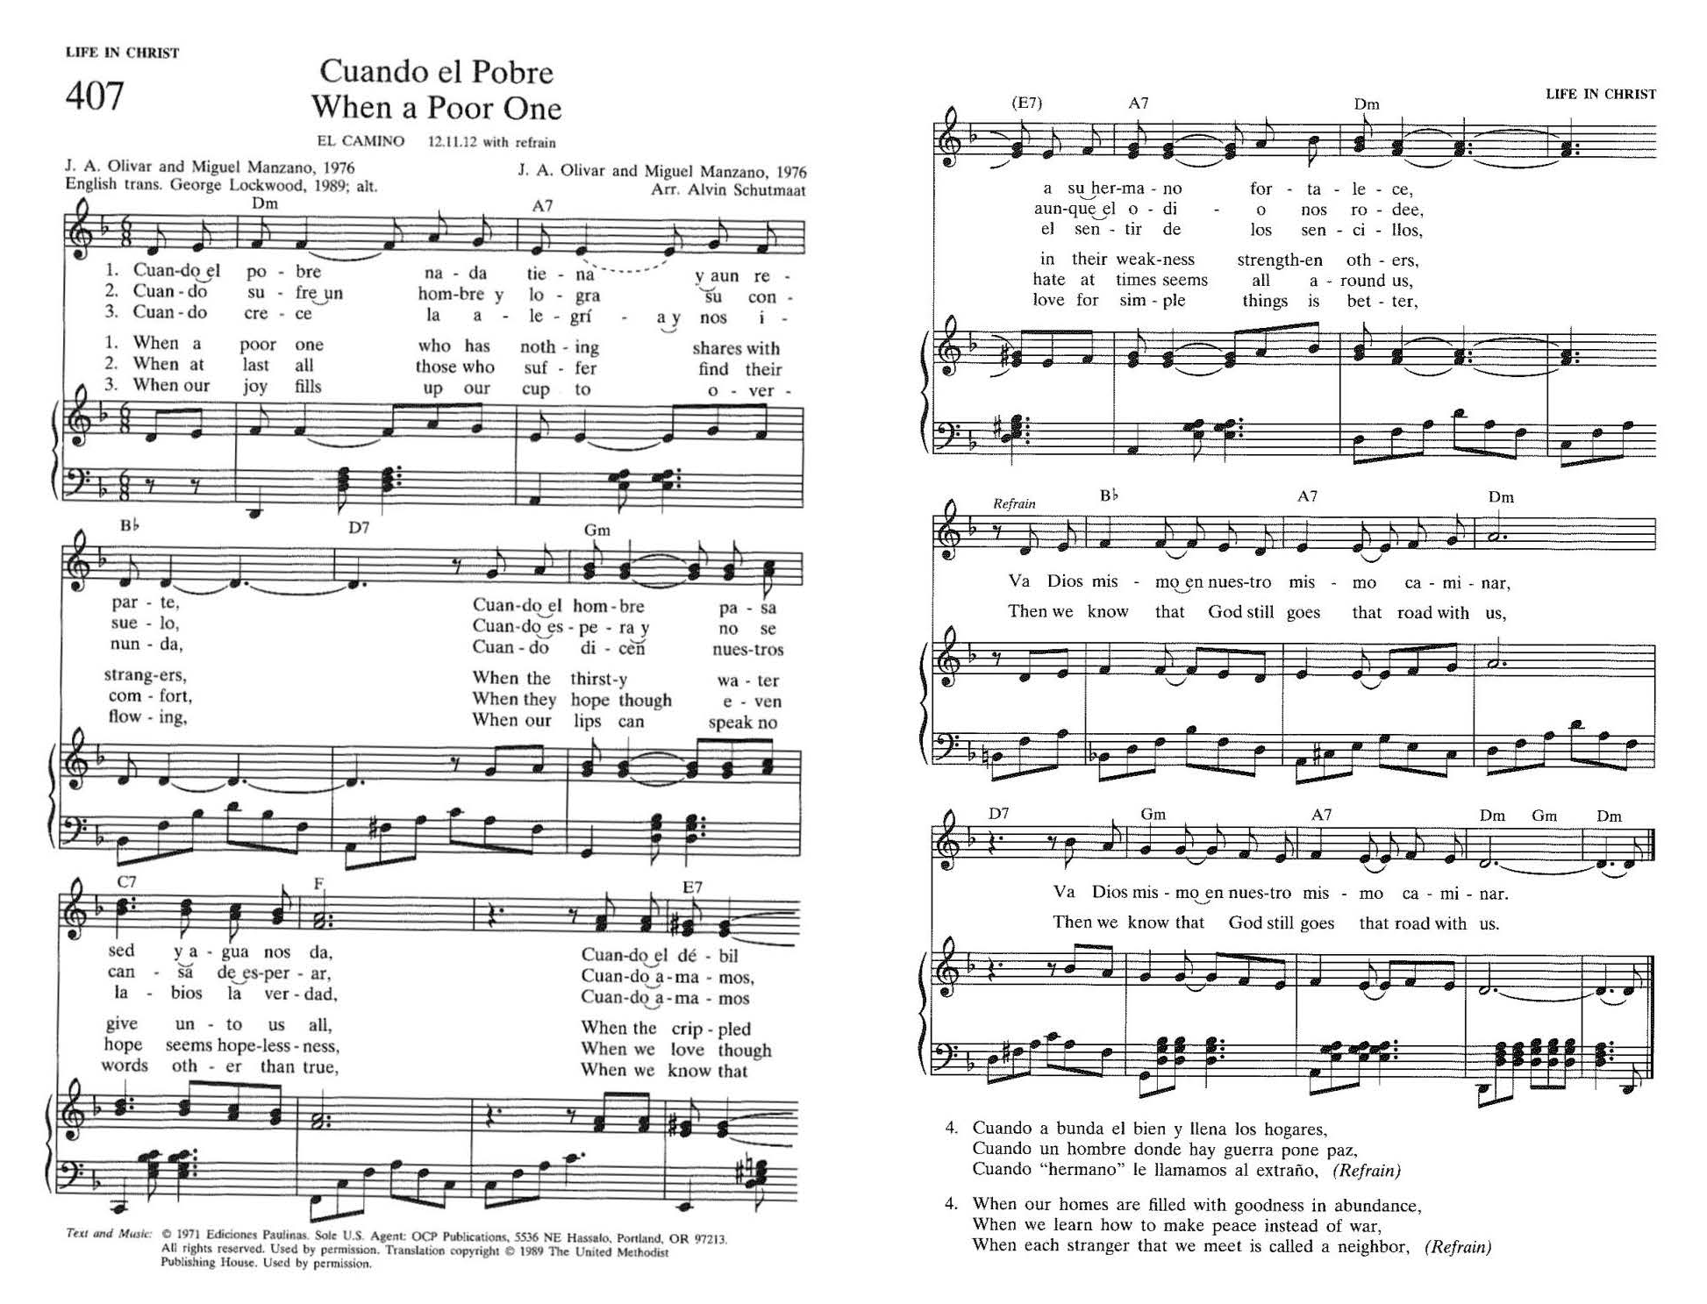
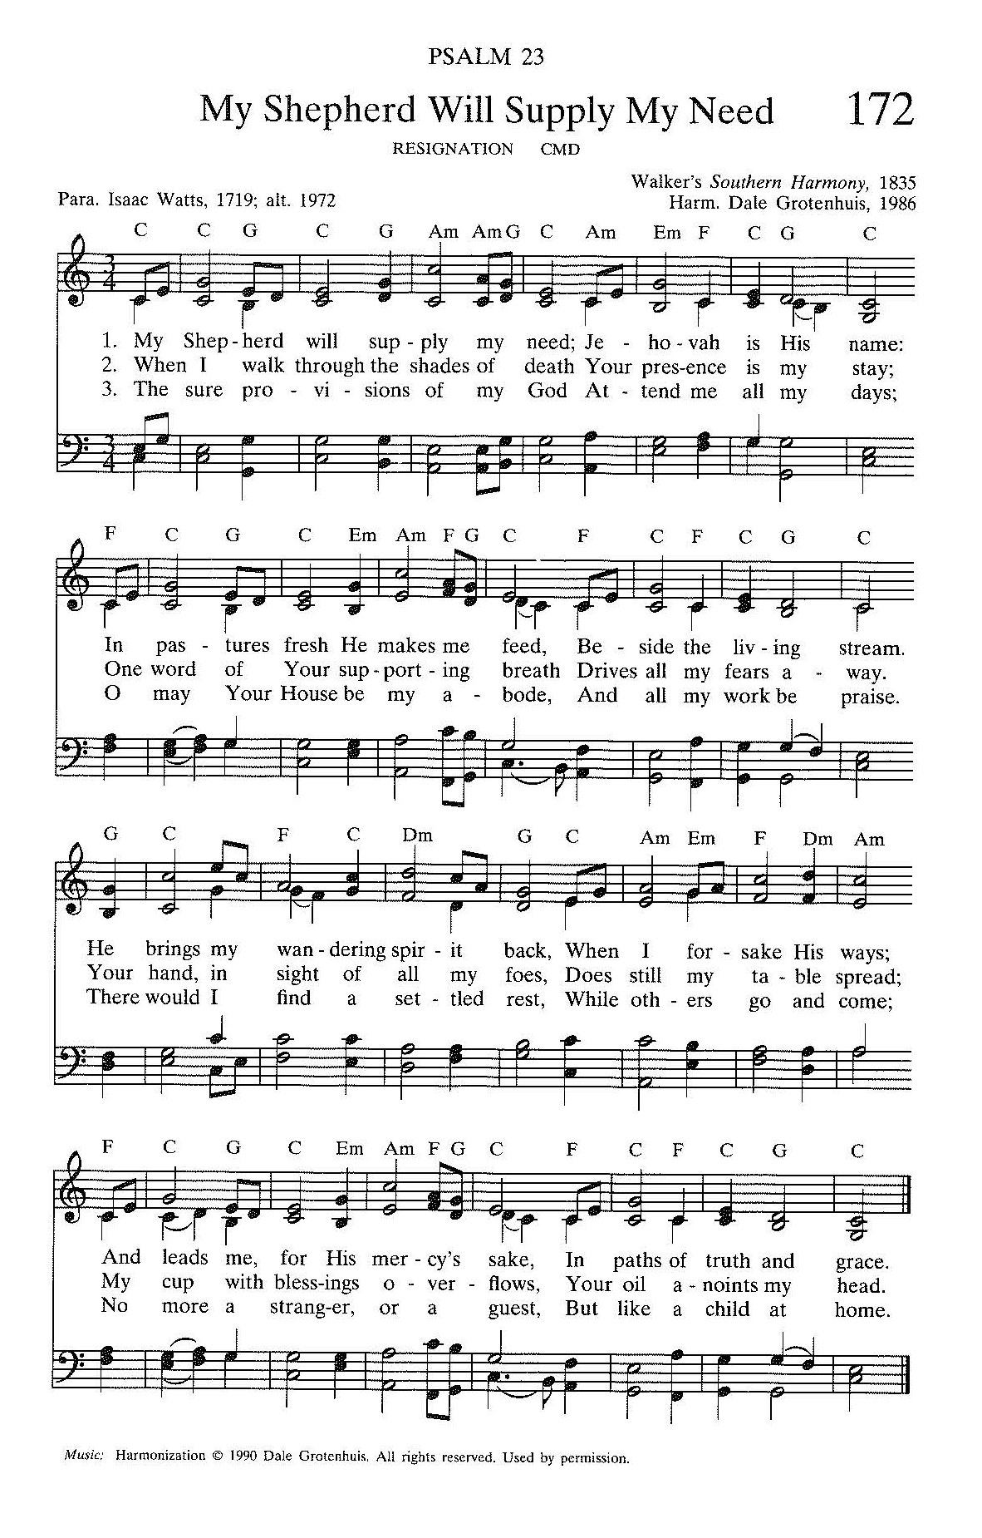

The 4th of July is next week! Families and individuals concerned about the gun violence crisis in America are invited to march in Haddonfield's parade. You do not need to be a member of Moms Demand Action for Gun Sense in America to participate. Simply come to Chestnut Street at Kings Highway at 9:30am and look for the bright red MOMS banner. No signs required but if you do bring one, please remember this is a family friendly event.

CONGREGATIONAL PRAYER LIST

Please pray for the following individuals and situations throughout the week. If you would like to add a personal prayer request, please contact one of the pastors or our new Office Administrator, Olivia Willison. Requests will be revisited every 30 days.

- Pray for the people, government, and country of Ukraine as war continues.
- Please pray for the Moody family of Pennsauken on the death of Dad Nate, who was a gasoline tanker driver in the I-95 crash. He leaves behind a wife and a 7 year old. The family is trying to make sense of this terrible tragedy (6/16- J. Wackes)
- Please pray for the family of Len Szyer of Philadelphia, the family patriarch who passed away following an illness (6/16-J. Wackes).
- Pray for healing for Antoine of Greenville, SC who is undergoing treatment for colon cancer in the ICU and for Terez and Wizard who are caring for him; may God give them strength and comfort (6/16-J. Wackes)
- Pray for Tony Gramkowski who is recovering from heart surgery and a stroke. He is in an ICU in Boston for his care (6/14 - MB Creamer)
- Please pray for Caroline Yount’s sister Michele as she recovers from back surgery (6/14-pastors).
- Please pray for Amy and Brad Strauss, that God would be present in their lives (6/13-pastors).
- Please pray for Mary Stringfellow who was hospitalized after suffering a fall (6/5-pastors)
- Please pray for our Stephen Ministers who have begun new caring relationships (5/27-Stephen Leaders)
- Prayers for the family of friends of Anne Cooley who passed away this week (5/26-pastors)
- Pray for Hepsiba that she would receive God’s protection and guidance; also pray for spiritual growth and good health (5/26-pastors)
- Pray for Todd (5/24-N. Passante)
- Lift up prayers for Susan, who has just been diagnosed with brain cancer and a mass in lungs. Help her to feel God’s presence and strength (5/23-C. Carty)
- Keep Isabel Pross in your prayers as she undergoes cancer treatment (5/23-pastors)

Church Staff

The Rev. Dr. Marvin Lindsay, Senior Pastor and Head of Staff – mlindsay@haddonfieldpres.org
The Rev. Nikki Perrine Passante, Associate Pastor – npassante@haddonfieldpres.org
Peter Leibensperger, Minister of Music – pleibensperger@haddonfieldpres.org
Lucas Brown, Principal Organist – lbrown@haddonfieldpres.org
Katie Beth McBurnie, Director of Children’s Ministry – kmcburnie@haddonfieldpres.org
Nancy Ruth Wainwright, Director of Children’s Choirs – nancyruthw@comcast.net
Marisa McGovern, Preschool Director – preschool@haddonfieldpres.org
Kris Bean, Business Manager – kbean@haddonfieldpres.org
Travis Bogetti, Building Manager – tbogetti@haddonfieldpres.org
Ed Hess, Community Caseworker – edwh517@aol.com
Olivia Willison — officeadmin@haddonfieldpres.org

Olivia Willison, a rising junior at Mount Holyoke College, is joining our staff as Office Administrator this summer! Olivia is a member of FPCH, a veteran of our children’s choirs, and a former nursey attendant. Please send your information for the bulletin, calendar, and Weekly News to Olivia at the email address above.

20 Kings Highway E, Haddonfield, NJ 08033 ♦ www.haddonfieldpres.org ♦ (856) 429-1960

